**A Creative Approach to Social Media.**

Daniel T. Daley

**ABSTRACT**

**myCircle** is the concept and prototype of a social media platform built around peoples interests and hobbies as opposed to lifestyle sharing**[1]** and content reposting. Many current platforms of social media do not offer much space for individuality or customisation of the content that users see from friends or people that they follow or are friends with (beyond unfriending or unfollowing them), as well as customisation of the small amount of space users are given on such platforms. As social media and the online presence of individuals is very important in modern times**[2],** I will be looking to make my platform a more customisable approach to social media in regards to the content that users choose to see.

**INTRODUCTION**

On current iterations of social media platforms, there are typically not many ways to filter content (if such functionality is in place at all), which can render much of the content feed irrelevant. Some platforms offer groups where communities can be formed but it is most often the case that the majority of the group are not actually people within your friends list, which can once again deem the content irrelevant. On platforms such as Facebook, pages exist in which users can ‘Like’ to follow as a means to keep up with certain interests, but the fellow users within this space are not exclusively part of the users friends list. In a similar fashion users can search for particular ‘hash-tags’ on Instagram and although the user will be presented with any and all posts containing that particular tag, it is posts from the whole community that the user will be presented with, not just those that the user has chosen to be friends or affiliate with. With **myCircle**, users will be able to manage their content feeds by adding or removing interest circles. These will act as filtered feeds in which they would only be presented with posts relating directly to that field of interest, or all posts from friends that are part of that circle, the user will have the choice between a strict or more social circle setting. Upon posting into such circles, users will also have the option to strictly post into that circle, keeping that post away from users who do not follow such circles and preventing said post from being visible on people general feed, where the majority of posts from all friends will be available. This will give users more control over the full reach of the content they post themselves and offer an added layer of privacy to their social media experience.

**BACKGROUND RESEARCH**

Many studies towards the effects of social media on mental health have been conducted and it is generally common knowledge that there are both positive and negative impacts to consider when you are a user of such platforms**[3].** The aim with myCircle is to get users to engage more with their hobbies and interests and create posts around such things, in contrast to a comparative lifestyle approach that is quite often seen on social media that has been seen and noted to have adverse effects on mental health leading to such things as depression and low self-esteem. “The frustration of logging into an OSN and being flooded with friends’ notifications showing perfect happiness and flawless lives. Seeing that others are seemingly better off than oneself is aversive for most people” **[1].** A social media platform built around interests and hobbies could have a positive impact on mental health of individuals of all ages **[2].** “Nowadays social media has become a new set of cool tools for involving young people. Many young people’s day to day life are woven by the social media. Youngsters are in conversation and communication with their friends and groups, by using different media and devices every day” **[3].** **myCircle** is a social media platform built around the idea of bringing friends, both real-life and online, closer together through shared interests and hobbies.

**TIMELINE**

With a development time to provide a minimum viable product being around the five-week mark, time available was split into main focus points for each week or sprint and was to follow an Agile methodology **[4]** of implementation and refinement. Week one focused on front end UI (user interface) development, week two aimed for server and routing functionality leaving weeks three and four for database architecture/implementation and further refinements respectively. As development progressed passed week one, which remained front end and user interface focused, the main focus of the following weeks became a little more blended as certain database functionality required extra front-end components or vice-versa in order to fully test those certain aspects were working properly.

**SYSTEM**

The front-end system is built using React.js alongside the Material-UI React library for stylings. React, developed by Facebook, with its use of states and how the technology handles user sessions and cookies make this a great fit for this project. Initially I had my reservations towards using this technology, having never really developed something with it on my own, but soon found my feet with it and can gladly say I will be using it for projects going forward. The back end is developed with Node.JS, Express for server functionality, Multer for media upload handling and Crypto for sensitive data hashing. MySQL is used for the data storage solution for this system, chosen based on its capabilities to use data tables relationally and securely. Initially I forecasted requirements for a database with two tables, Users and Posts **(see figure 1)**. This was loosely based off of a previous project I had been working on, which was a form of blogging platform in which post creation along with image uploading was functional and seemed like a viable starter template to build this projects storage solution on top of.

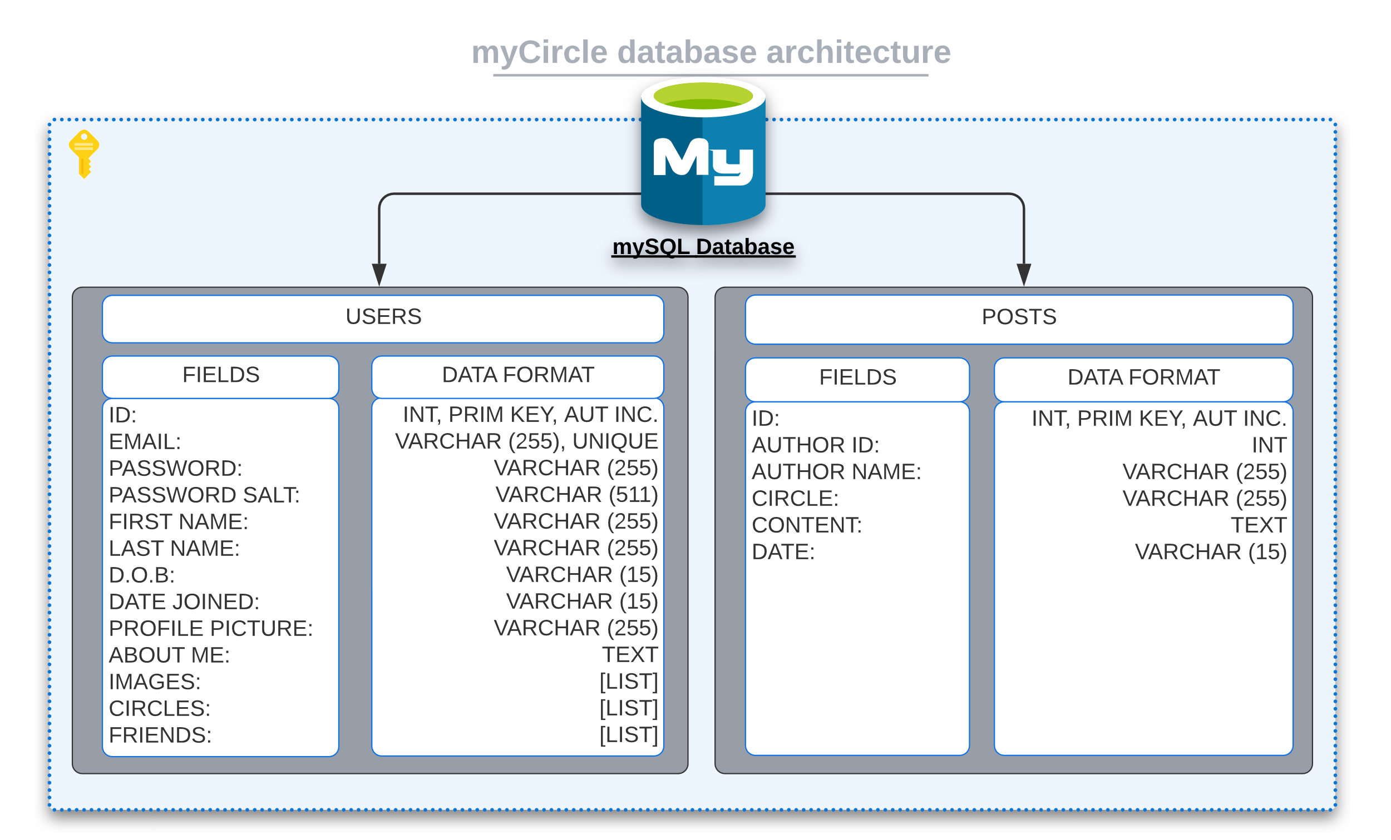

Figure 1 Initial database architecture

As development progressed and more functionality was added, the requirements of the database grew vastly in order to be able to grab data effectively and in a more effective manner. The database grew to hold eight tables, six more than the number forecasted **(see figure 2)**.

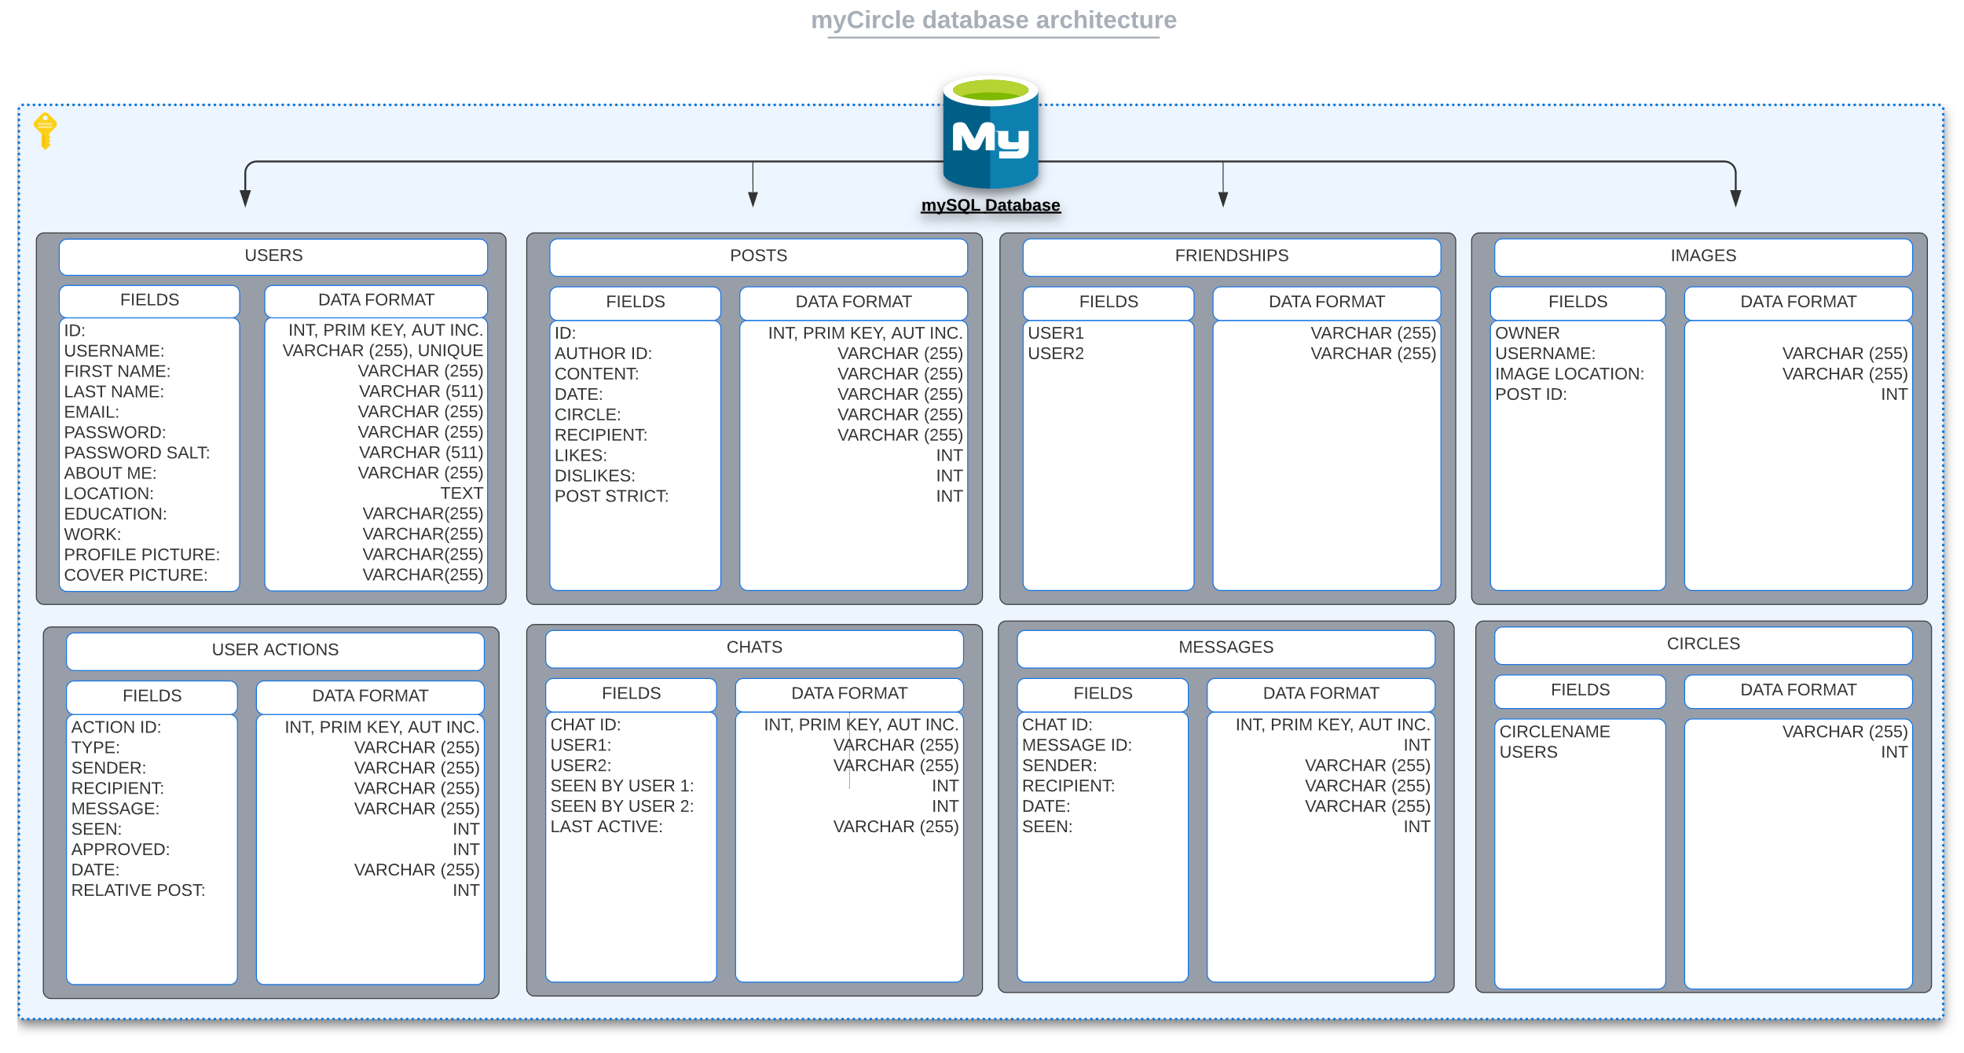

Figure 2 Database architecture at end of dev.

The justification for the additional tables was to be able to access data more effectively and more specifically where needed, allowing the system to find data that matched a more focused criterion. For example, fetch all messages where the chat ID (the chat in which a message relates to) matches the ID of the chat in question, and then order those messages by the items independent ID or date. The creation of the images table allowed for not only the removal of the “image” field on the post column, but also allowed for multiple images to be attached to a single post. The feed would find the post, and then append all images from the images table where the “relative post ID” matches that of the current post, and then present the data accordingly. A similar approach is applied for listing all of a user’s images on their profile, and so on. See figure 3 for a more comprehensive visual of how the classes are structured throughout the front end of the system.

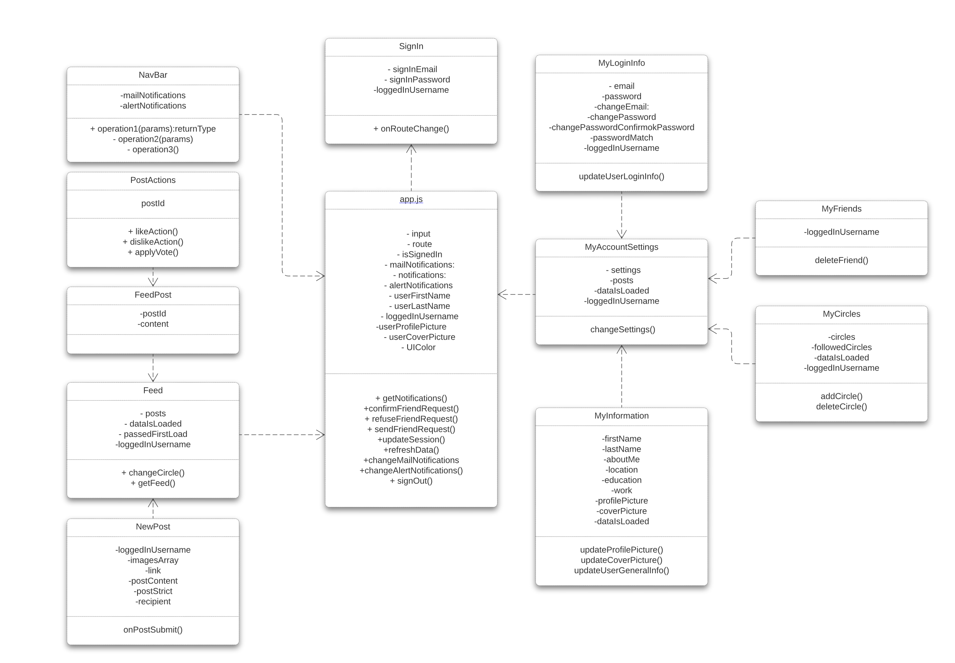

**FUTURE DIRECTION**

Given more time, some things that I would have loved the chance to build into the platform is profile customisation in order to give users the option to be able to change the layout of their user profiles and change the colour schemes of the user interface that they are presented with upon login. The chat system which currently updates the state of the chat window and posts to the database would be replaced with web sockets for a less server heavy approach to the chat system. This method would be much more efficient and leverage more advanced web features, but with the time constraints the system in place works reasonably well for a functioning prototype. As it stands, the platform in its current state does not offer responsiveness in terms of scaling the user interface into a more mobile friendly version. As the majority of today’s social media users tend to use their preferred platforms from their mobile devices, this will be an important step to implement. The only data currently hashed in the database is users’ passwords. As other user data such as names and email addresses are still considered sensitive, added functionality to hash said data will be another

Figure 3 Application class hierarchy.

important step towards safeguarding user information that is required for the platform to function properly. I would also conduct some research to see if this approach to social media would tempt people to engage more with their hobbies and interests and conduct said research in a similar fashion to Rahman, M.M **[5]**

**CONCLUSION**

With a social media platform centred around interests and hobbies, I feel that users could feel more inclined to engage in these activities in a social environment, bringing about a new medium to share and collaborate with new and existing friends from both the online and real world. This platform could take the focus away from the comparative lifestyle approach to social media, which has been seen to contribute towards detrimental mental health habits **[1][3]**, and more towards creativity and engaging in creative activities and perhaps even aid in learning new skills and giving users a new space to pick up new interests.

**References**

**[1]** Appel, Helmut; Crusius, Jan; Gerlach, Alexander L. (2015). Social Comparison, Envy, and Depression on Facebook: A Study Looking at the Effects of High Comparison Standards on Depressed Individuals. Journal of Social and Clinical Psychology, 34(4), pp.278.

**[2]** Iwasa, H., Yoshida, Y., Kai, I., Suzuki, T., Kim, H. and Yoshida, H., 2012. Leisure activities and cognitive function in elderly community-dwelling individuals in Japan: a 5-year prospective cohort study. Journal of psychosomatic research, 72(2), pp.159-164.

**[3]** Siddiqui, S. and Singh, T., 2016. Social media its impact with positive and negative aspects. International journal of computer applications technology and research, 5(2), pp.71-75. http://www.ijcat.com/archives/volume5/issue2/ijcatr05021006.pdf

**[4]** Everything you need to know about agile project management. (Accessed 30/03.2022) https://www.teamwork.com/project-management-guide/agile-project-management/

**[5]** Rahman, M.M., Saifuzzaman, M., Ahmed, A., Mahin, M.F. and Shetu, S.F., 2021. Impact of COVID-19 on mental health: A quantitative analysis of anxiety and depression based on regular life and internet use. Current Research in Behavioral Sciences, 2, pp.100037.